Rough HPV Screening Modelling Results, 3rd March 26
Calibration results
All added to manuscript (methods section)

Comparing algorithms at 80% projected vaccine uptake
I have not got the full grid of pairwise algorithm comparisons yet, but we get the picture from the following selection of comaprisons.

In the plots below all values are given ‘per 3 months’, so multiply by 4 to get annual rates (also means that the cancer elimination target is at vertical line y=1, not y=4, for these plots). All are rates per 100k susceptible women. Showing means over all sims. Timepoints are ‘quarters since 2000’, so 0 is year 2000, 100 is year 2025, 200 is year 2050.
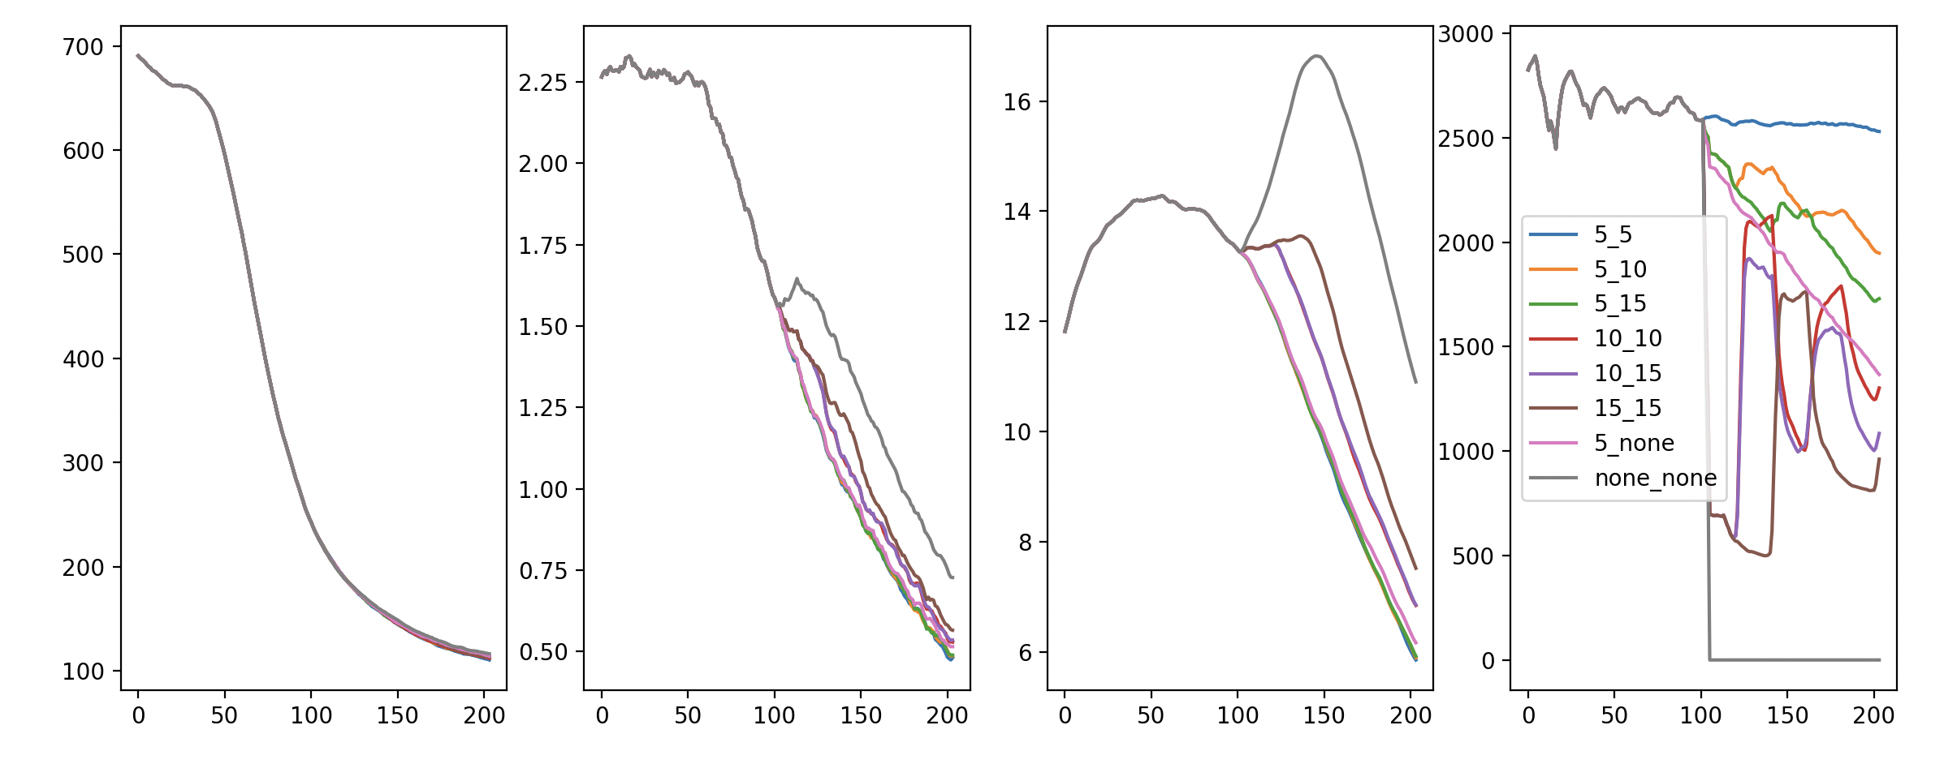
Compares HPV infection incidence (very left), cervical cancer prevalence (middle left), women with undiagnosed cervical cancer after 5 years (middle right), number routine screens (very right) for screening everyone every 5, 10, 15, years. Also compares screening unvacc every 5 years + vacc every 10,15, years. Also screening unvacc every 10 years and vacc every 15 years. Finally compares with no screening anyone ever beyond 2026, and also only screening unvaccinated beyond 2026.

We see very little effect of screening on HPV incidence, as expected.

In terms of cancers: Patterns are clearer when looking at the ‘5-year undiagnosed cancer prevalence’ plot (3rd along), which shares the same shape as the cancer incidence plot but smoother. If we screen unvacc every 5 years, there is little change if we reduce screening for vaccinated down to every 10 or 15 years. We do start seeing a difference beyond around 2035 if we totally cut out vaccinated screening however. There is a similarly negligible difference between screening everyone every 10 years compared to screening unvaccinated every 10 and vaccinated every 15 years. However, there is a big difference between 5-yearly screening and 10-yearly screening overall, and about the same difference again between 10-yearly and 15-yearly screening. We can conclude this is mostly driven by cancers in unvaccinated individuals. As expected, completely removing screening for everyone yields a big spike.
The demand for routine screens are as expected – bigger intervals yield fewer required screens.

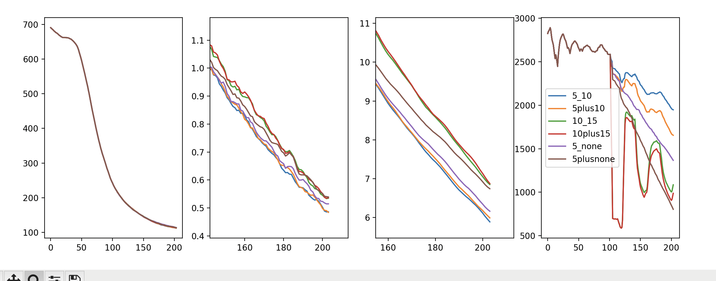
Panels layed out like previous figure. Here we compare screening interventions which are (a) specific to vaccination status (i.e. unvacc individuals screened every (5,10,5) years while vacc individuals screened (every 10 years, every 15 years, NEVER)), vs (b) cohort-wise – that is, specific to whether an individual was every offered a vaccine – (i.e. older individuals not offered vaccine screened every (5,10,5) years and individuals offered a vaccine screened (every 10 years, every 15 years, NEVER)

Again, the incidence and screens are as expected.

If we are to offer X-yearly screening to some and Y(>X)-yearly screening to others, we will minimise cancers if X-yearly screening is offered specifically to unvaccinated individauls and Y-yearly specifically to vaccinated individuals, rather than broadly doing things cohort-wise. The difference between the two options (personalised according to vaccination status vs cohort-wise) gets more pronounced in later years, expectedly– but is not as pronounced as maybe expected. For X,Y=5,10 and X,Y=10,15, there is not a very big difference between the two options. However, there is a massive difference when it comes to fully removing screening from a population (which of course is not on the table policy-wise, but as discussed with Kate is included for completeness): especially as the years progress and there is a bigger proportion of vaccinated adults, it is very important to continue screening unvaccinated individuals, even if they are part of a cohort that were offered a vaccine as a child.

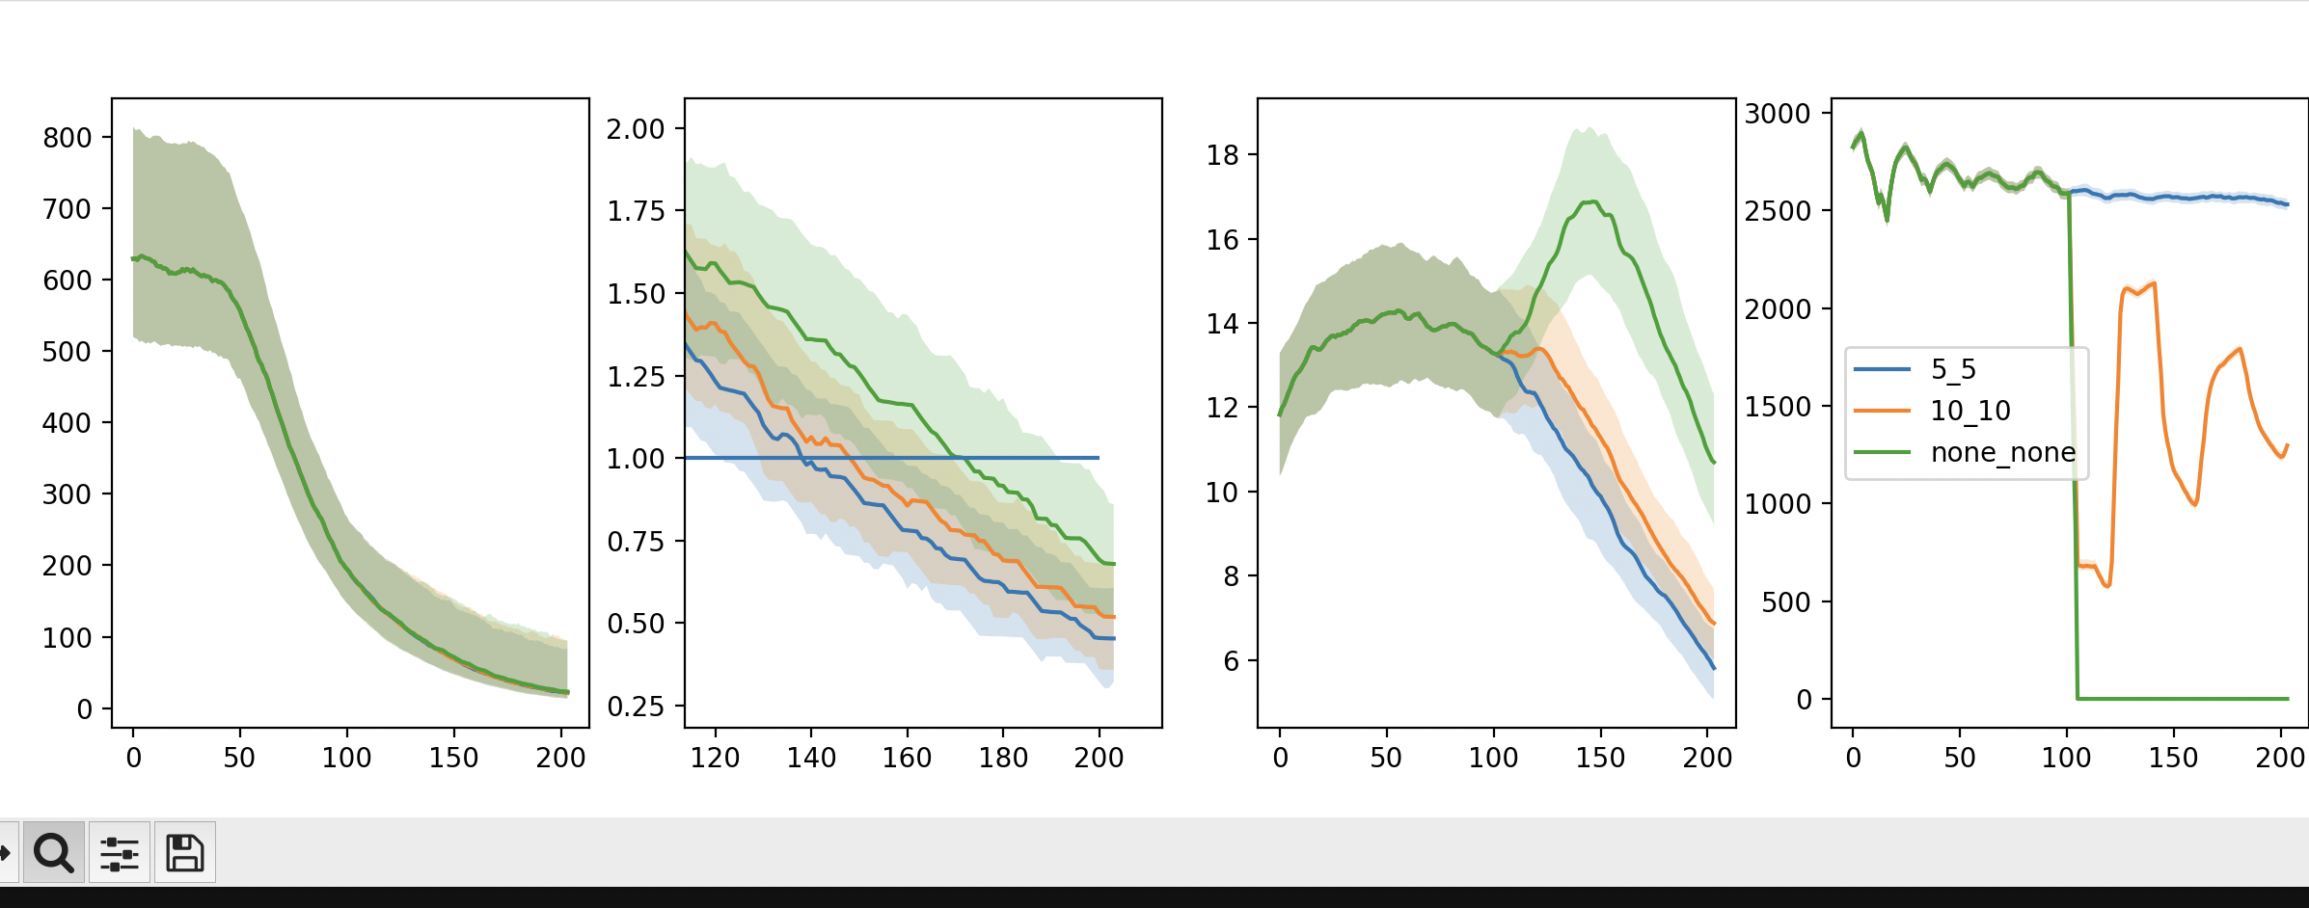
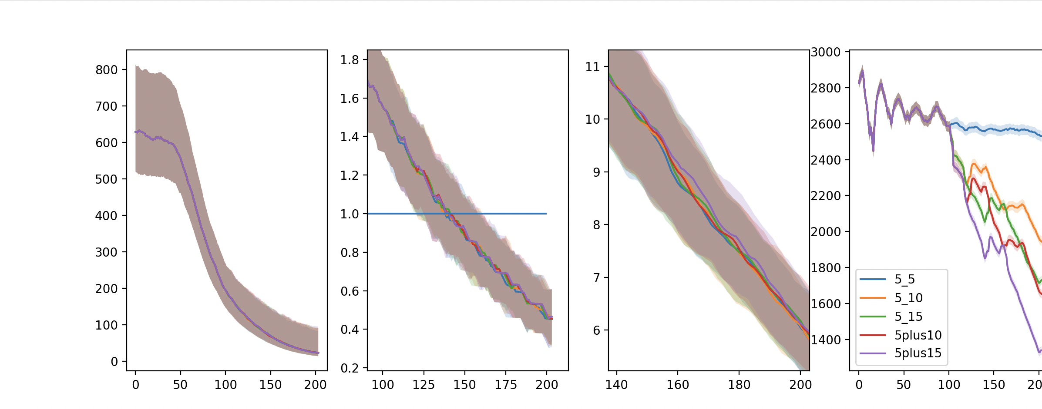
A similar pair of plots to before (same panel meanings) but this time with medians plotted and the region between the lower and upper quartiles shaded in. I am just showing 3 algorithms in the top one not to clutter the space and have added a line at the NHS target for cervical cancer elimination. The bottom plot just shows the algorithms with 5-yearly screening for unvaccinated/cohorts not offered vaccination

Under all algorithms which retain 5-yearly screening for unvaccinated women OR retain 5-yearly screening for individuals not offered the vaccine, we don’t see much difference in the central 50th percentile of outcomes (other than number of screens) and crucially all have a similar probability of elimination by 2040 of >80%). This probability reduces if we reduce screening for unvaccinated individuals.

Equity
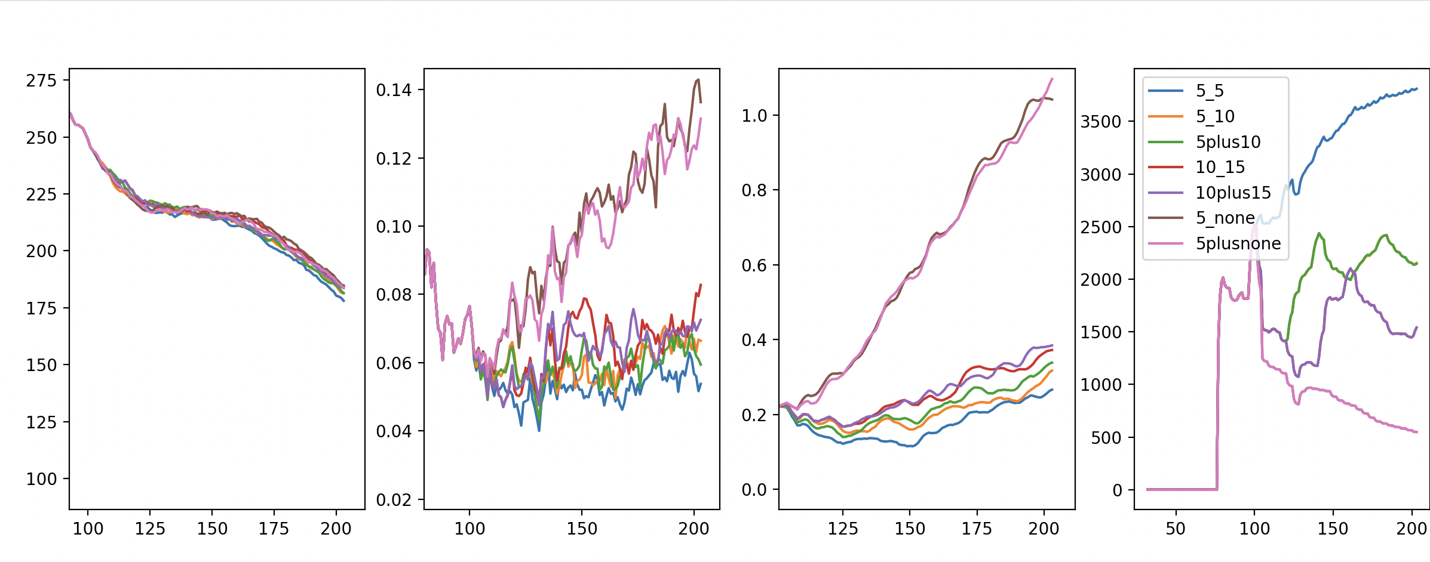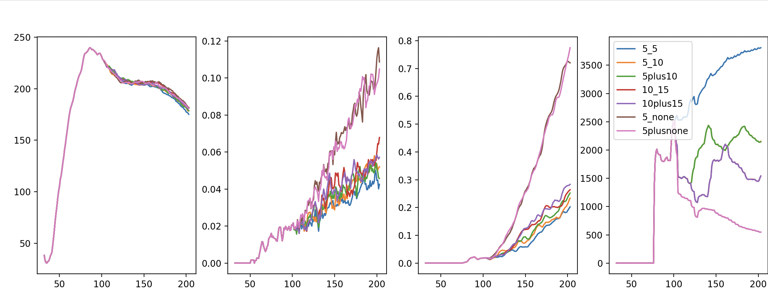
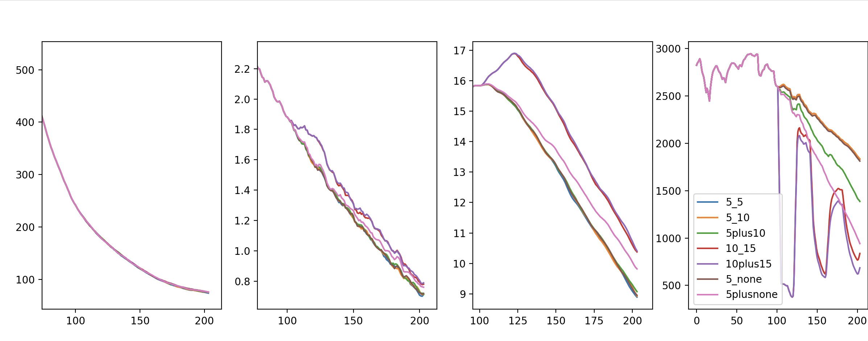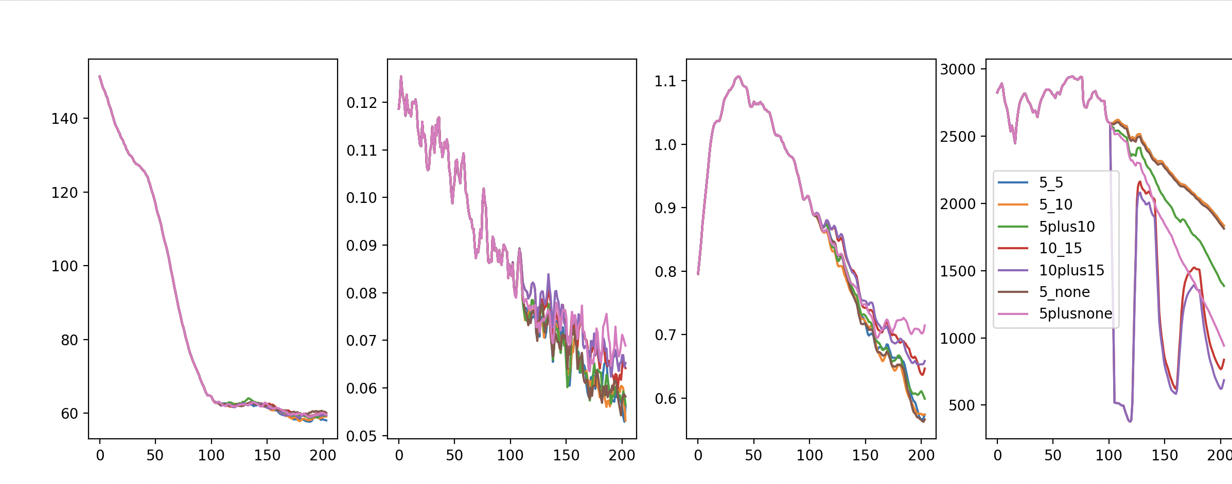

A 2x2 table of results where each quarter is a panel of results as before. Top row is just the vaccinated population, bottom row is jjust unvaccinated population. Left side is counting incidence and cancers across all genotypes, right side is counting incidence and cancers across just genotypes not directly protected by the vaccine.

Among vaccinated indivudals, any screening changes from the current policy does increase rates (as expected). However, we notice clearer differences between individual-wise and cohort-wise changes in this vaccinated subpopulation; there is a higher rate of cancer among vaccinated individuals when we reduce screening for the unvaccinated counterparts in the same cohort as them. This is likely explained by HPV incidence: unlike when we aggregate over the full population, HPV incidence when restricted to the vaccinated population does vary notably between algorithms, and when we do screening on a cohort-wise (rather than individual-wise) basis, we allow for greater spread of HPV that is noticed in the vaccinated subpopulation. It is notable, however, that in this subpopulation, rates of infection and cancer are still very low. Almost all infections and cancers across the wider population occur in unvaccinated individuals , and their trends drive the wider trends we see across the previous analysis (in which we analysed over an aggregated population of all individuals). We note that most cancers in unvaccinated individuals are attributable to the genotypes covered by the vaccine, however almost all cancers in vaccinated individuals are attributable to the genotypes not covered by the vaccine.

A sensitivity analysis over different vaccine uptakes (LV=60% vs base case 80%)
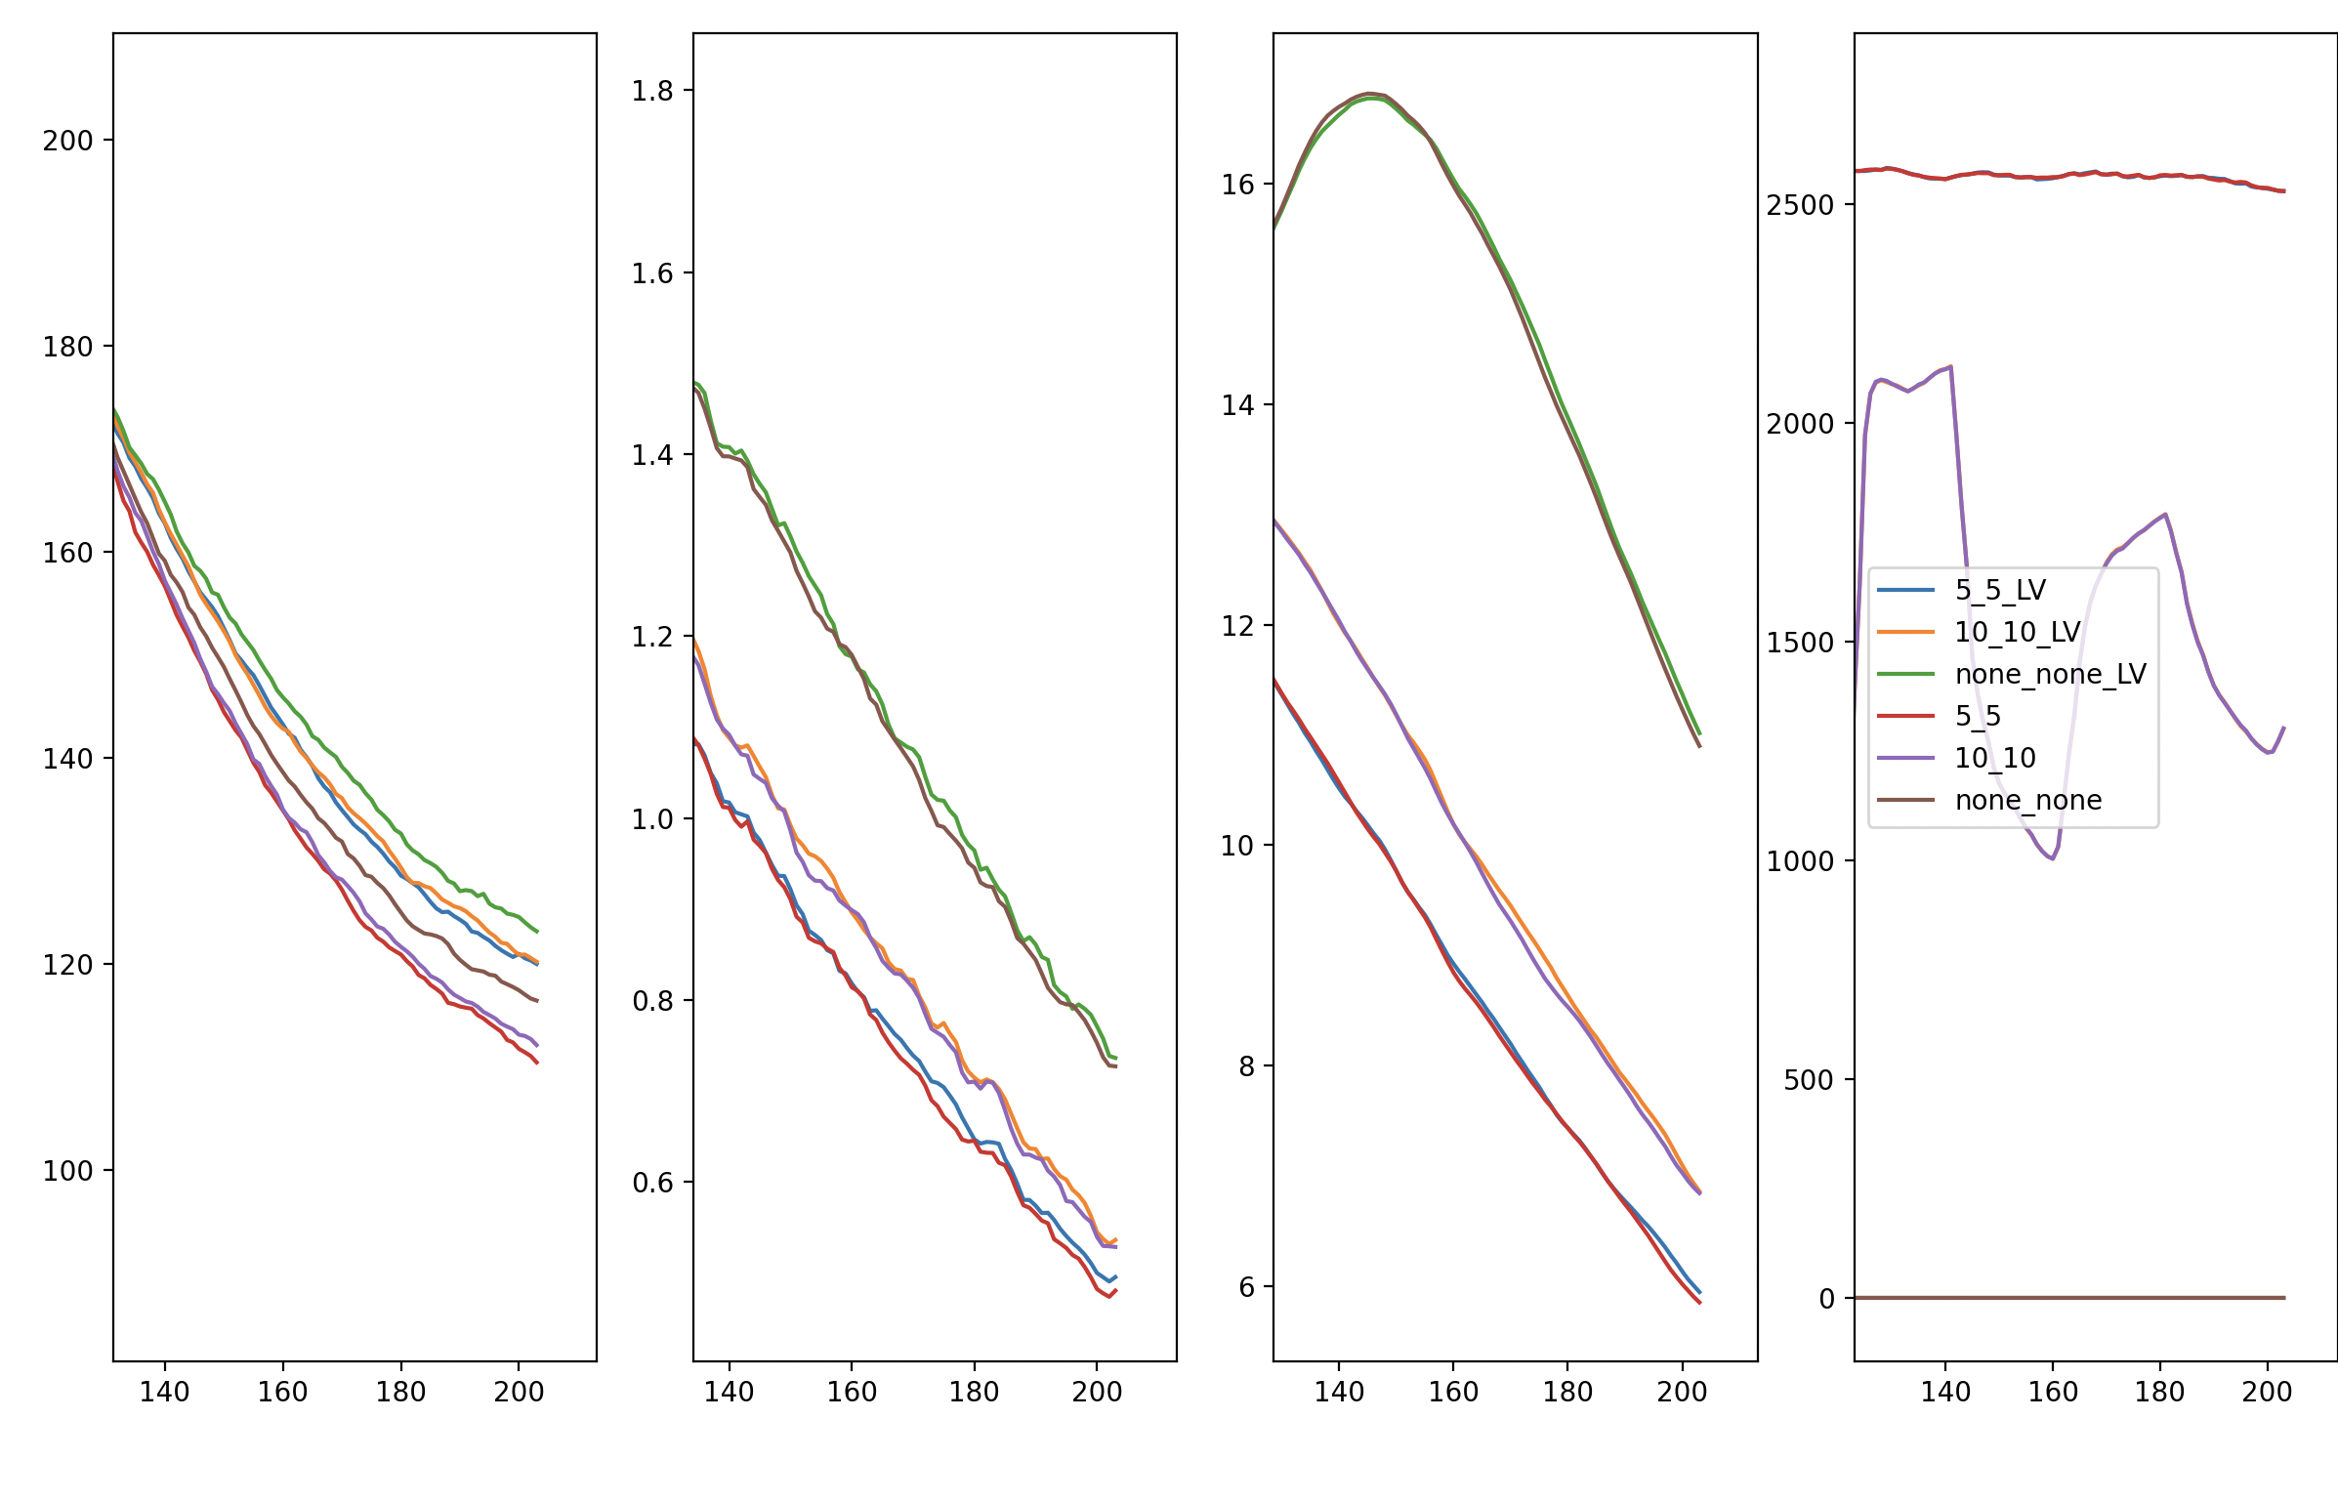
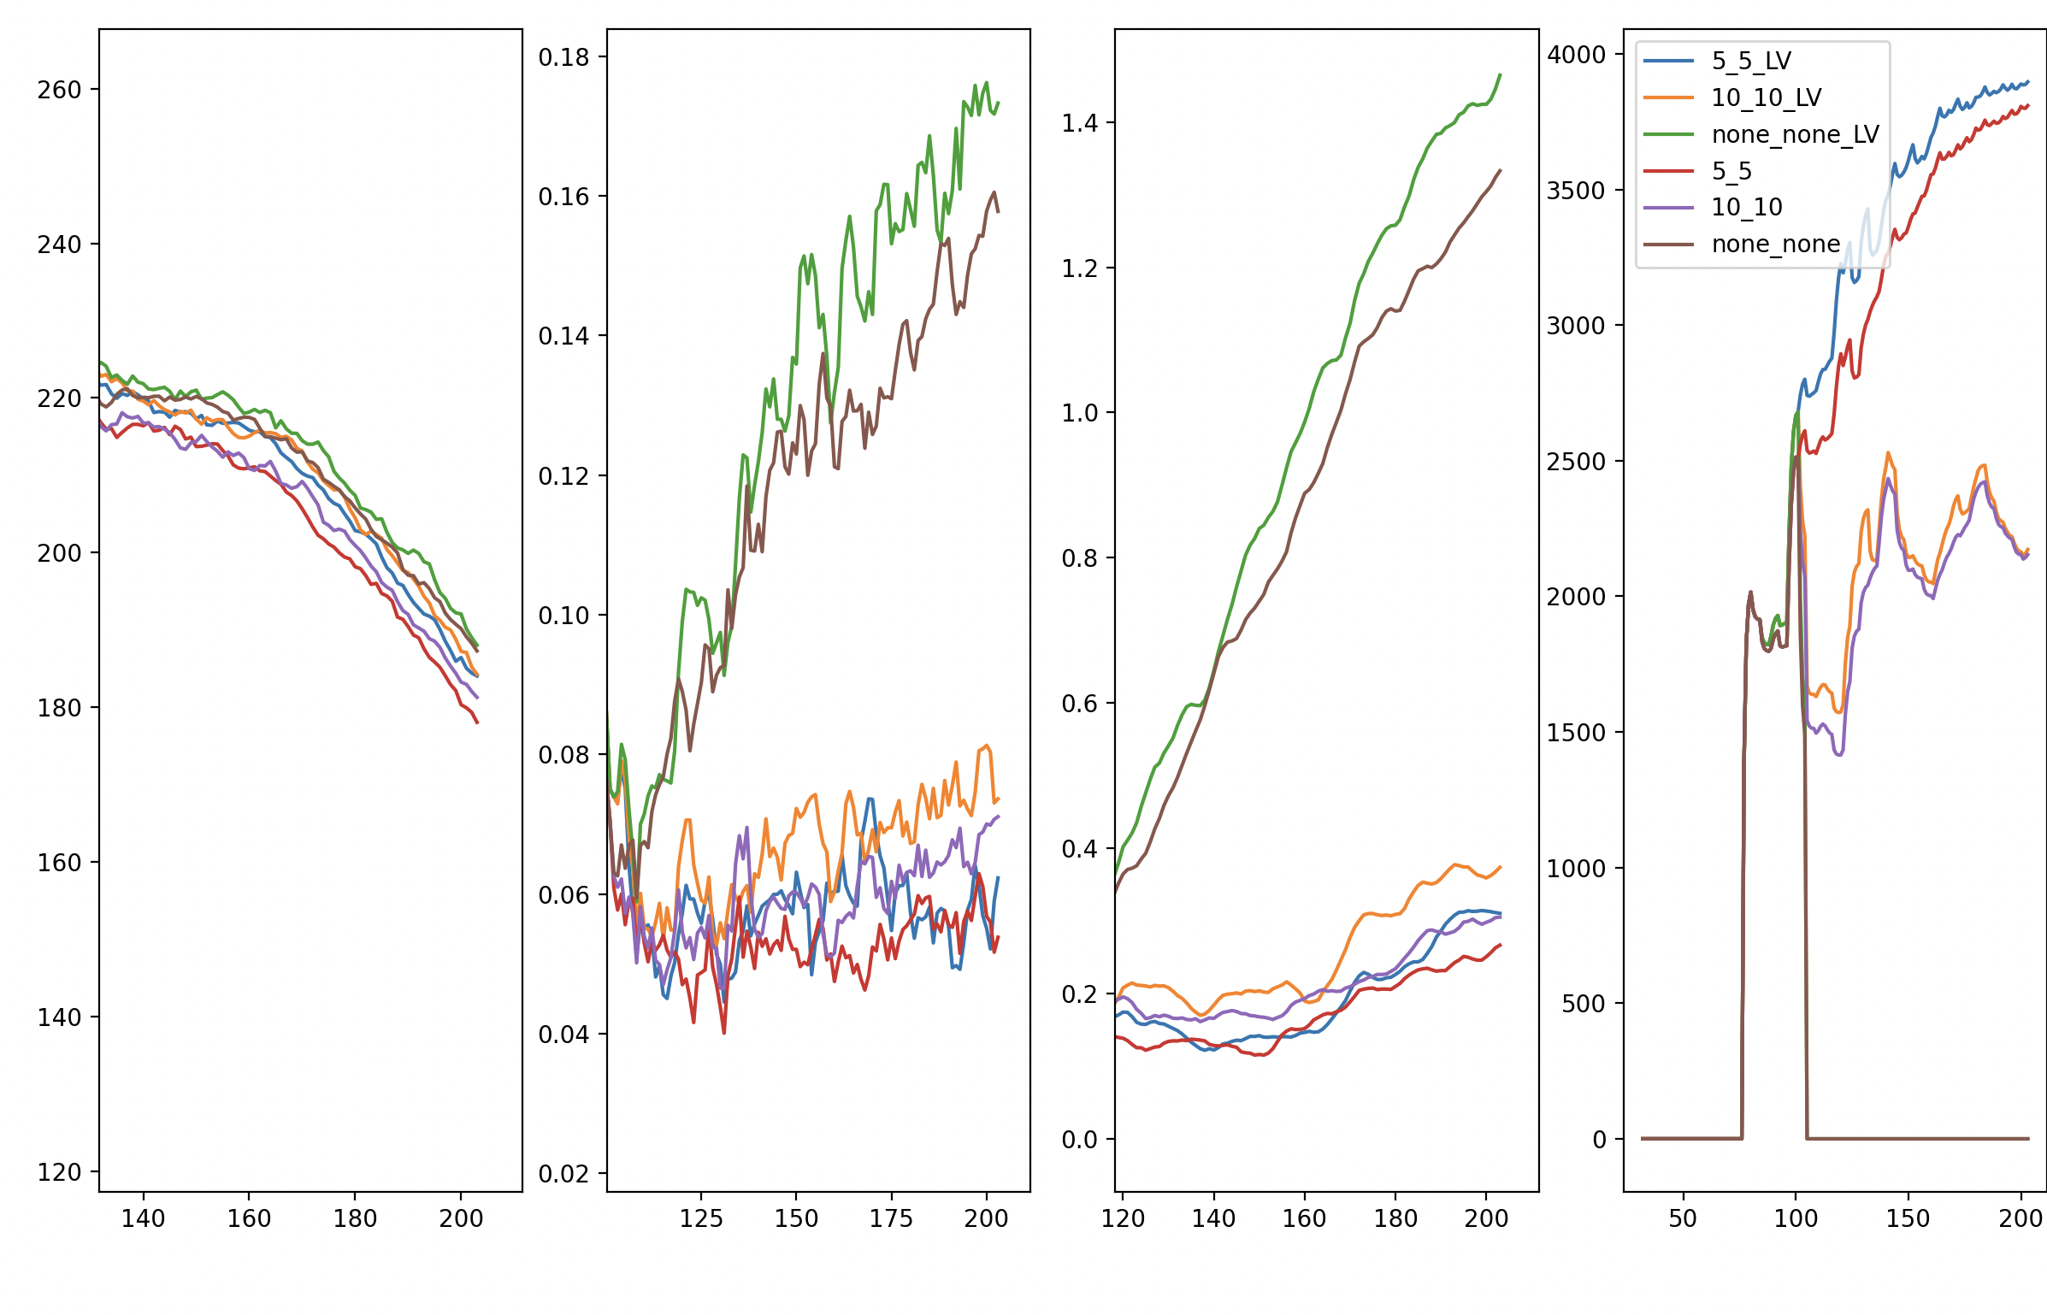
comparing the algorithms under low vaccination vs the target of 80% for the full population (top) and focussing on the vaccinated population (bottom)
We see that there is a minor worsening of both infections and cancers in the overall population with a lower vaccine uptake, with the not-too-big difference consistent with a herd effect being seen to some extent below 60% for the HPV vaccine. However, when focussing on the vaccinated subpopulation we see that more regular screening is of greater importance for the vaccinated under low vaccine uptake, as they are less protected by an existing-but-still-less herd effect. Under lower uptake, any policy which does not screen vaccinated at all is even worse than before, and policies which screen vaccinated more frequently become more reasonable. Cohort-wise policies become less reasonable.

